**Exploring the Motor Driver BTS7960 43A**

**Important specs**

* Input Voltage: 6-27V
* Max Current: 43A (Which is why we removed the heat sink, motor is 5.4A)

**Parts of the BTS**

B+ | B- | M+ | M-

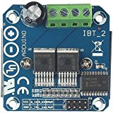

**Green housing**

* M+ and M- is to supply power from the 12V battery to the motor
* B+ and B- is for the battery input

**Headers**

* **VCC** and **GND** is to allow the BTS to work (Connected to 5V and GND on Arduino)
* **RPWM** and **LPWN** are to control the **motor directions and speed**. Magnitude determines the speed. Connected to PWM.
* **R_EN** and **L_EN** are to control which directions the motors are allowed to rotate. (These are connected to digital pins). If both are set to high, it means the motor can rotate both forward and backward. If both are low, then the motors cannot rotate in either direction.
* **R_ls** and **L_ls** are for current outputs and can be used to monitor the current flow

**Connecting the BTS to the arduino[1]**

**Basic Circuit diagram**

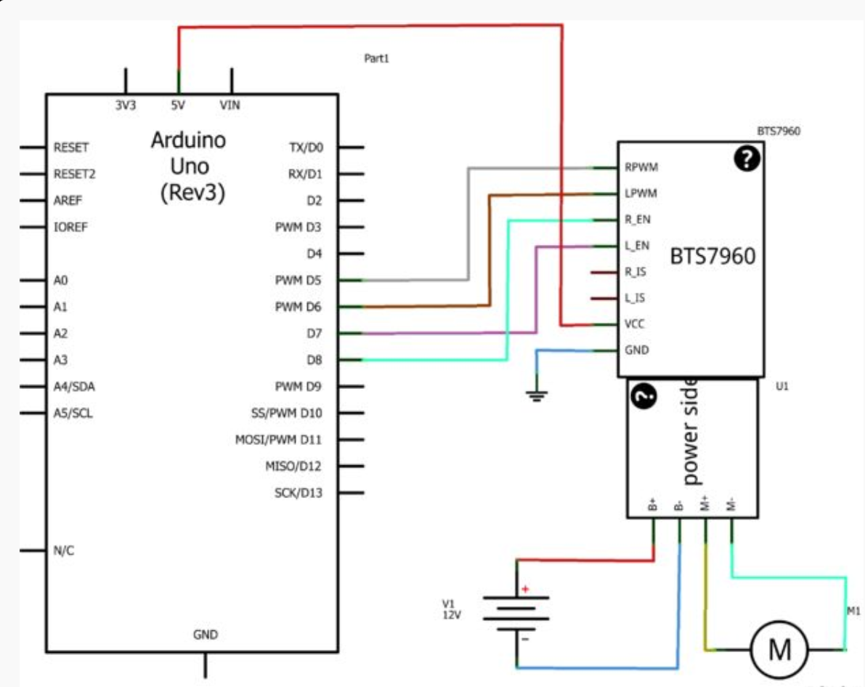

**Testing if the BTS has an internal voltage regulator**

**Procedure**

* We connected the lead acid battery directly to the BTS.
* We then used a multimeter to test the potential difference across the VCC and GND headers

**Conclusion**

* Multimeter did not produce the 5V we expected
* The 5V and GND headers are mainly for the Arduino to input into the BTS (Note the difference between BTS and L298 5V and GND)

**Testing the BTS**

**Circuit set-up**

A circuit board

Description generated with very high confidenceA circuit board

Description generated with very high confidence

**Code**

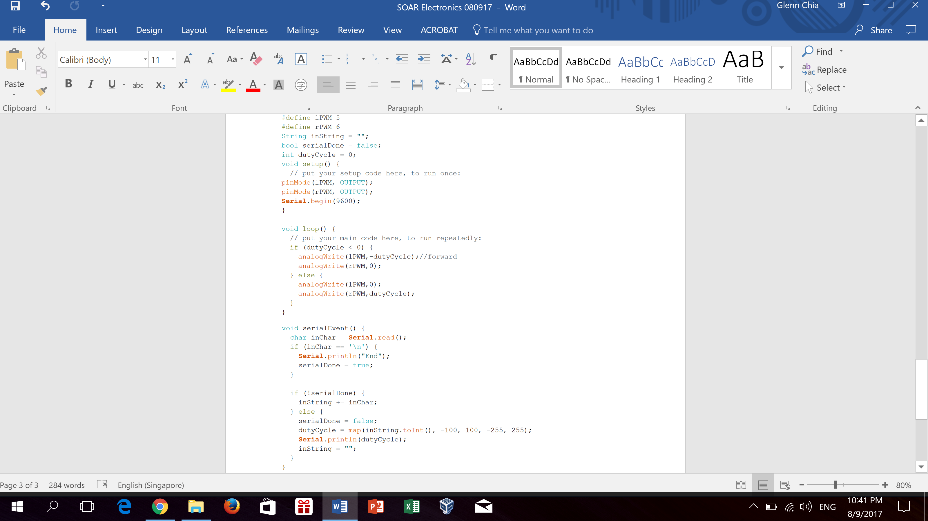

The speed and direction of the motors were changed via the Serial Monitor

**Note**

* BTS does not work without the enable pins even though the Arduino sets PWM values to the PWM headers. Enable pins are assumed to be of value LOW if not connected to the Arduino and assigned HIGH.
* We need to plan on the hardwide side how to mount the LiPo, RPI, Arduino Uno, 02xBTS, LIDAR and UBEC

1. http://www.instructables.com/id/Motor-Driver-BTS7960-43A/